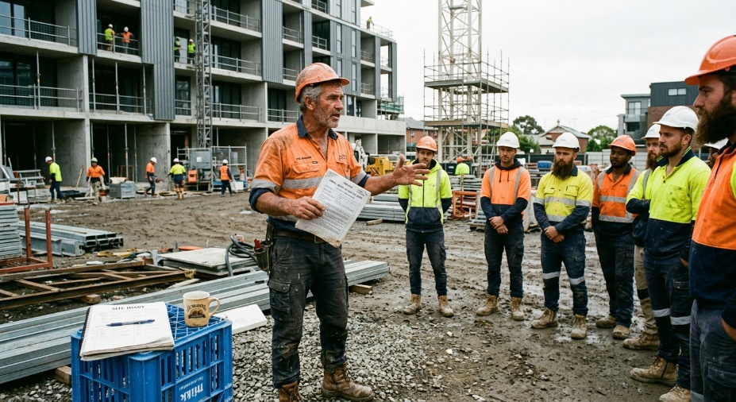
Learner #6: Mick O'Reilly

About Me: | Mick is a 58-year-old Lead Carpenter and sub-contractor based in South Australia, currently working with Apex Builds on the Southbank Apartment Complex in Adelaide. He has been on the tools for thirty-five years and is the designated Health and Safety Representative for his crew. Mick lives in the southern suburbs with his wife; their two adult children have long since moved out, and most of his after-hours time goes into running his own small sub-contracting paperwork from his ute or the kitchen table.
Professional and Learning Experience: | Mick holds CPCCWHS1001 (White Card), CPCCOHS2001A (Apply OHS requirements, policies and procedures), and HLTAID003 (Provide First Aid, currency to be reconfirmed). He completed his carpentry trade certificate in the late 1980s. His practical experience covers thirty-five years of formwork and framing, fit-out and finishing, plan reading and setting out, SWMS and JSA development, and a significant amount of HSR work including weekly toolbox talks, hazard inspections, and SWMS sign-offs.  He has mentored at least eight apprentices through to completion across his career and is currently supervising two second-years (Jake and Liam) at Southbank. Recent work includes a stint in the Mile End rail corridor delivering platform formwork, where he handled the rail safety fundamentals well, and ongoing pressure-jetting work at the Southbank promenade. Mick is enrolled in TAE40122 with the long-term aim of moving into a Site Safety/Trainer role.
Career/Training Goals: | Mick has been candid that “the knees are buggered” after thirty-five years on hard surfaces and that the move into training is largely driven by the need to get off the tools entirely over the next few years. He has a planned arthroscopic procedure on his right knee scheduled for July, with the orthopaedic surgeon already flagging that a partial knee replacement is likely within five years. His GP has told him bluntly that he should expect to spend less time kneeling, climbing, and on his feet from here on. His goal is to transition into a full-time WHS and training role with a builder or RTO over the next 18 to 24 months and to wind down toward semi-retirement in his mid-60s.
Working Style and Preferences: | Mick is a confident, highly experienced verbal trainer. His morning toolbox talks are consistently well-attended and well-received; he can stand up in front of fifteen to twenty trades workers and explain scaffolding interfaces, exclusion zones, and 100-percent tie-off requirements in plain, direct language they actually take in. His apprentice mentoring is hands-on, demonstration-led, and patient.  The picture changes considerably the moment a screen is involved. Mick's most recent performance review rated his Reporting and Admin at 2 out of 5, with the Site Manager specifically noting that signed SWMS often sit in his ute for a week before they reach the office, that he openly resents the company's iPad-based site induction app, and that the business has had to nominate a “Digital Buddy” (one of the younger chippies) to help him upload site photos and hazard reports to the Apex Portal. Mick keeps almost all of his notes in a hard-cover site diary and writes up his toolbox minutes by hand; the typed-up version usually lands on the office desk a week later, if at all.  He owns a basic laptop at home but uses it almost exclusively for invoicing and quoting in software his bookkeeper set up for him years ago. He has mentioned that he has never had a personal email address that he checks regularly. His wife handles anything that needs to be done online for the household, and that the idea of submitting an assessment through an online portal is “the bit that worries me most” about the Cert IV. His apprentice training records are signed monthly “from memory” rather than maintained as a running log. Mick is on his feet for the bulk of his working day and finds extended desk-based sessions physically uncomfortable; he prefers to be able to stand, move, or take short breaks during longer training, and has mentioned that sitting in one position for more than 30 to 40 minutes makes his knees seize up.
Additional Information: | Mick is a long-standing member of his local Men's Shed and runs a weekend cricket umpiring roster in summer. His preferred way of learning anything new is to watch someone do it once, then have a go himself; he avoids reading-heavy training material and has mentioned that he often skips to the diagrams in any technical document. He has flagged early in conversation that he will “definitely need a hand” with the digital learning platform used by the RTO and has half-jokingly asked whether anyone can come and “drive the computer” for him on assessment day.

